**Scotts Mills Firefighters Association**

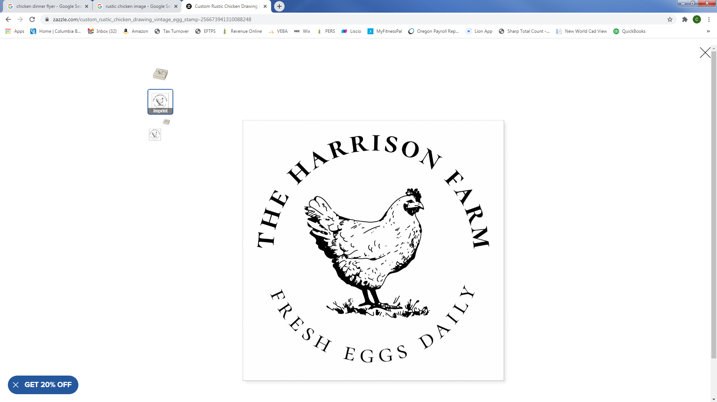

46th Annual

Chicken

Dinner

**Funds support local**

**community**

**Drive-thru Only**

**JOIN US!**

Scotts Mills Fire Station

490 3rd St

Scotts Mills, OR 97375

**OCT 19th**

**4:30pm - 7:00pm**

**PRICING**

**Seniors $12 Adults $14**

**Under 12 $10**

**Check, Debit or Credit Card Preferred. Limited Cash on Hand.**